ABAVN -

Functionality
Asset retirement is the removal of an asset or part of an asset from the asset portfolio. This removal of an asset (or part of an asset) is posted from a bookkeeping perspective as an asset retirement.

Scenario
SAP provides the following types of retirement:
- An asset is sold, resulting in revenue being earned. The sale is posted with a customer.
- An asset is sold, resulting in revenue being earned. The sale is posted against a clearing account.
- An asset has to be scrapped, with no revenue earned. (Illustrated here)
- An asset is sold to an affiliated company (refer to Manual Posting of Intercompany Asset Transfer/Retirement)

Requirements
Check the date specifications, and make any necessary entries on the Transaction data tab page. If you do not enter an asset value date, the system automatically determines this date when you save.

Menu Path | Accounting → Financial Accounting → Fixed Assets → Posting → Retirement → ABAVN - Asset Retirement by Scrapping
Transaction Code | ABAVN

1. Double Click on ABAVN - Asset Retirement by Scrapping

Enter Asset Transaction: Asset Retirement by Scrapping

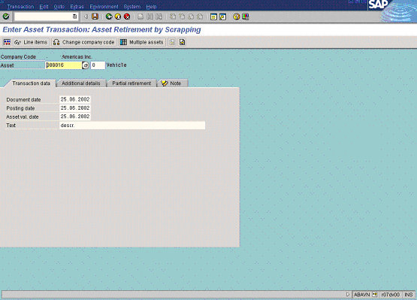
2. Update the following fields:

Field Name | Field Description | Values
Asset | This is the number which, together with the asset sub-number, identifies a fixed asset in Asset Accounting. | Example: 800016
Document date | Date the transaction occurred | Example: 250602
Posting date | Date that the business transaction occurred | Example: 250602
Asset val. date | The asset value date is the value date for Asset Accounting. | Example: 250602
Text | Contains an explanatory text on the line item. | Example: Scrapping of old assets..
3. Click the Enter button to validate the entries.
4. Click simulate Button to check that the values entered.

Enter Asset Transaction: Asset Retirement by Scrapping

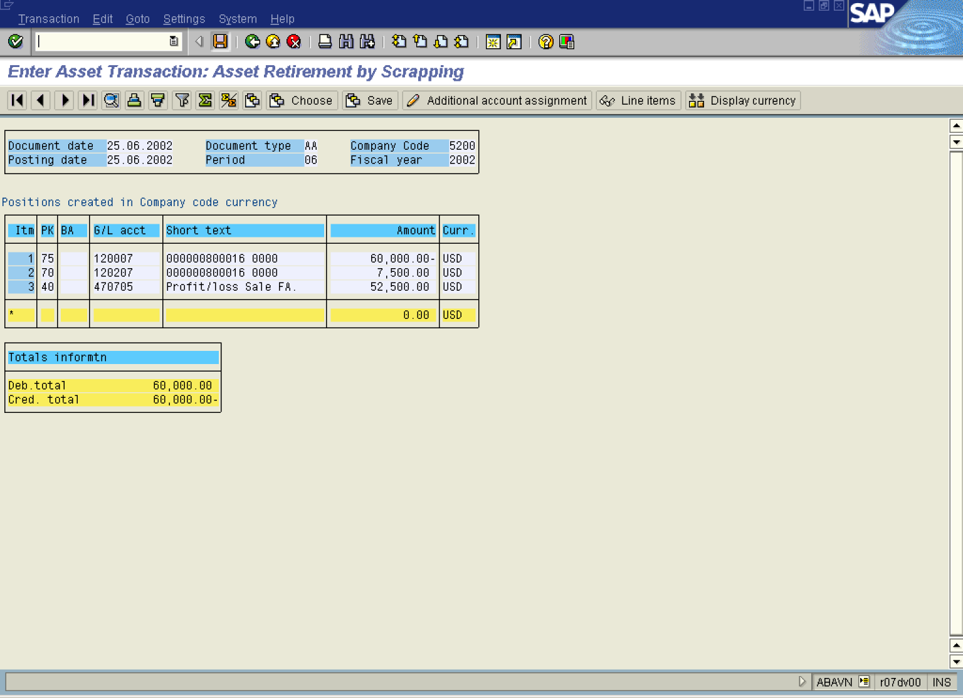

5. Click the Save button.
6. The message bar displays “Document XXXXXXXXXX was posted.”

